CC_1

727721EUIT043

GURU VISHNU S

Question 1 :

Adding a product to cart and checkout : •

Verify that user is able to add a product to the cart Add to cart • Verify that user can view the contents in the cart •

Verify that once user clicks on checkout button “Your information” form should be displayed

Verify that once user fills the form and clicks on continue button entire product overview should be displayed •

Print the name of the product and the price of the product • Assert the title of the page is ‘Swag Labs’ •

Asser t the URL of the page is ‘https://www.saucedemo.com/checkout-step-two.html’

package com.selenium.test2.selenium1;

import org.openqa.selenium.By;

import org.openqa.selenium.WebDriver;

import org.openqa.selenium.WebElement;

import org.openqa.selenium.chrome.ChromeDriver;

import org.openqa.selenium.chrome.ChromeOptions;

import io.github.bonigarcia.wdm.WebDriverManager;

public class cc1_1{

public static void main(String[] args) throws InterruptedException {

WebDriverManager.chromedriver().setup();

ChromeOptions co=new ChromeOptions();

co.addArguments("--remote-allow-origins=*");

WebDriver driver=new ChromeDriver(co);

driver.get("https://www.saucedemo.com/inventory.html");

driver.manage().window().maximize();

WebElement usernameField = driver.findElement(By.id("user-name"));

WebElement passwordField = driver.findElement(By.id("password"));

WebElement loginButton = driver.findElement(By.id("login-button"));

usernameField.sendKeys("standard_user");

passwordField.sendKeys("secret_sauce");

Thread.sleep(1000);

loginButton.click();

WebElement addToCartButton = driver.findElement(By.id("add-to-cart-sauce-labs-backpack"));

addToCartButton.click();

Thread.sleep(1000);

WebElement cartBadge = driver.findElement(By.id("remove-sauce-labs-backpack"));

String t=cartBadge.getText();

if(t.equals("Remove")) {

System.out.println("Item is Added to Cart");

}

// View the contents of the cart

WebElement cartLink = driver.findElement(By.className("shopping_cart_badge"));

cartLink.click();

WebElement cart = driver.findElement(By.className("title"));

String a=cart.getText();

if(a.equals("Your Cart")) {

System.out.println("Your Cart is Viewed");

}

Thread.sleep(1000);

WebElement checkoutButton = driver.findElement(By.id("checkout"));

checkoutButton.click();

WebElement check= driver.findElement(By.className("title"));

String b=check.getText();

if(b.equals("Checkout: Your Information")) {

System.out.println("Your Information Form is Displayed");

}

Thread.sleep(1000);

WebElement firstNameField = driver.findElement(By.id("first-name"));

WebElement lastNameField = driver.findElement(By.id("last-name"));

WebElement postalCodeField = driver.findElement(By.id("postal-code"));

WebElement continueButton = driver.findElement(By.cssSelector(".btn_primary.cart_button"));

firstNameField.sendKeys("guru");

lastNameField.sendKeys("vishnu");

postalCodeField.sendKeys("125");

Thread.sleep(1000);

continueButton.click();

WebElement over= driver.findElement(By.className("title"));

String c=over.getText();

if(c.equals("Checkout: Overview")) {

System.out.println("Product Overview is Displayed");

}

Thread.sleep(1000);

WebElement productName = driver.findElement(By.xpath("//*[@id=\"item_4_title_link\"]/div"));

WebElement productPrice = driver.findElement(By.xpath("//*[@id=\"checkout_summary_container\"]/div/div[2]/div[8]"));

String name=productName.getText();

String price=productPrice.getText();

System.out.println("Product Name: "+name);

System.out.println("Product Price : "+price);

String tit=driver.getTitle();

if(tit.equals("Swag Labs")){

System.out.println("Title of the page is Correct");

}

String u=driver.getCurrentUrl();

if(u.equals("https://www.saucedemo.com/checkout-step-two.html")){

System.out.println("URL of the page is Correct");

}

}

}

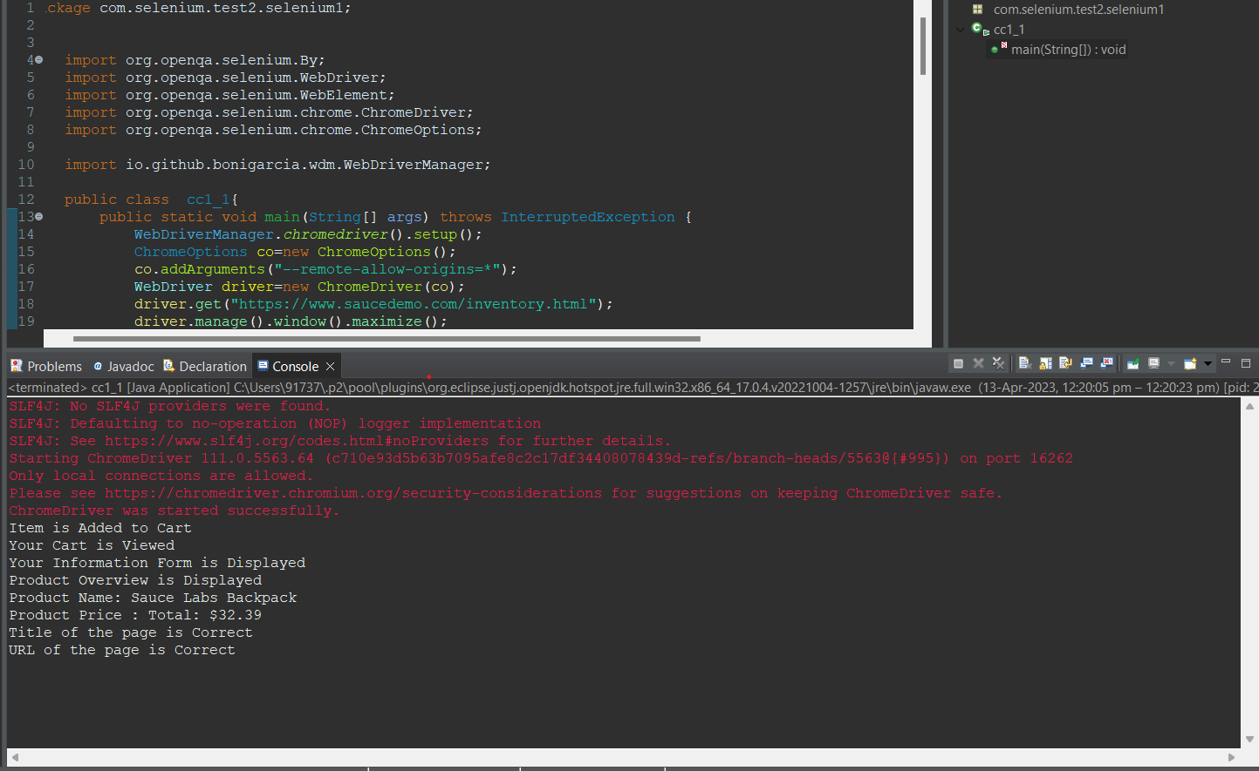

QUESTION 2 :

Filter option : •

Verify that user is able to apply filter name wise from A-Z and Z-A

• Print the first product name while filtering from A-Z and print 1st product name while filtering from Z-A •

Verify the user is able to apply filter from low price to high price and high price to low price •

Print the 1 st product price while filtering from high to low and print 1st product price while filtering from low to high

package com.selenium.test2.selenium1;

import org.openqa.selenium.By;

import org.openqa.selenium.WebDriver;

import org.openqa.selenium.WebElement;

import org.openqa.selenium.chrome.ChromeDriver;

import org.openqa.selenium.chrome.ChromeOptions;

import org.openqa.selenium.support.ui.Select;

import io.github.bonigarcia.wdm.WebDriverManager;

public class cc1 {

public static void main( String[] args )throws InterruptedException

{

WebDriverManager.chromedriver().setup();

ChromeOptions co=new ChromeOptions();

co.addArguments("--remote-allow-origins=*");

WebDriver driver=new ChromeDriver(co);

driver.get("https://www.saucedemo.com/");

driver.manage().window().maximize();

WebElement sel=driver.findElement(By.id("user-name"));

sel.sendKeys("standard_user");

WebElement sel2=driver.findElement(By.id("password"));

sel2.sendKeys("secret_sauce");

WebElement sel3=driver.findElement(By.id("login-button"));

Thread.sleep(4000);

sel3.click();

WebElement sort1=driver.findElement(By.className("product_sort_container"));

sort1.click();

Select select= new Select(sort1);

select.selectByVisibleText("Name (A to Z)");

Thread.sleep(4000);

WebElement iden=driver.findElement(By.xpath("//*[@id=\"header_container\"]/div[2]/div/span/select/option[1]"));

if(iden.getText().equals("Name (A to Z)")) {

System.out.println("1.Verified that the user is able to apply the filter Name (A to Z)");

}

Thread.sleep(4000);

iden.click();

WebElement name=driver.findElement(By.xpath("//*[@id=\"item_4_title_link\"]/div"));

System.out.println("First product name while filtering from A-Z :-"+name.getText());

WebElement iden1=driver.findElement(By.xpath("//*[@id=\"header_container\"]/div[2]/div/span/select/option[2]"));

if(iden1.getText().equals("Name (Z to A)")) {

System.out.println("2.Verified that the user is able to apply the filter Name (Z to A)");

}

iden1.click();

Thread.sleep(4000);

WebElement name1=driver.findElement(By.xpath("//*[@id=\"item_3_title_link\"]/div"));

System.out.println("First product name while filtering from Z-A :-"+name1.getText());

WebElement iden2=driver.findElement(By.xpath("//*[@id=\"header_container\"]/div[2]/div/span/select/option[3]"));

if(iden2.getText().equals("Price (low to high)")) {

System.out.println("3.Verified that the user is able to apply the filter Price (low to high)");

}

iden2.click();

Thread.sleep(4000);

WebElement name2=driver.findElement(By.xpath("//*[@id=\"item_2_title_link\"]/div"));

System.out.println("First product name while filtering from Price (low to high) :-"+name2.getText());

WebElement iden3=driver.findElement(By.xpath("//*[@id=\"header_container\"]/div[2]/div/span/select/option[4]"));

if(iden3.getText().equals("Price (high to low)")) {

System.out.println("4.Verified that the user is able to apply the filter Price (high to low)");

}

iden3.click();

Thread.sleep(4000);

WebElement name3=driver.findElement(By.xpath("//*[@id=\"item_5_title_link\"]/div"));

System.out.println("First product name while filtering from Price (high to low) :-"+name3.getText());

}

}

